- BASICS OF SMPS AND UPS SYSTEMS

Q1. List 3 real-world devices in your home or college that use SMPS (Switched Mode Power Supply) and 2 devices that use UPS (Uninterruptible Power Supply), explaining in one line why each device needs that type of power supply.
ANS.
Device | Power Supply Type | Why It Uses This Power Supply
Desktop Computer | SMPS (Switched Mode Power Supply) | Converts AC power into the different DC voltages required by the computer components.
Laptop Charger | SMPS (Switched Mode Power Supply) | Efficiently converts AC power from the wall socket into DC power to charge the laptop.
LED Monitor | SMPS (Switched Mode Power Supply) | Provides stable and efficient DC power for the monitor's internal circuits.
Desktop Computer | UPS (Uninterruptible Power Supply) | Keeps the computer running for a short time during a power outage, preventing data loss.
Wi-Fi Router | UPS (Uninterruptible Power Supply) | Maintains internet connectivity during power cuts so the network remains active.

Q2. Draw and label a diagram showing the main internal components of a typical SMPS unit found in a desktop PC, including AC input, rectifier, transformer, and DC output sections. Hint: You can hand-draw and upload a photo, or use any free diagram tool like draw.io
ANS.
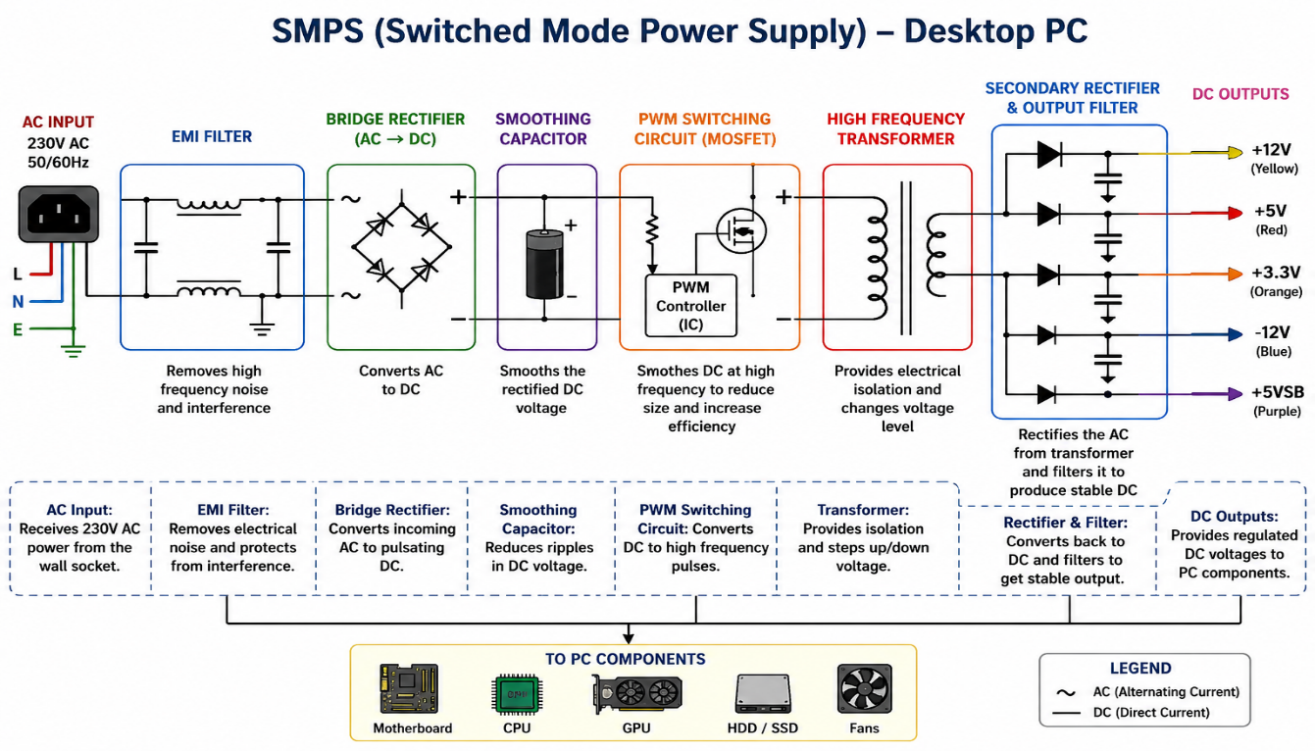

Q3. Take photos or find clear images online of the following power connectors: ATX 24-pin motherboard connector, SATA power connector, Molex connector, and PCIe 6/8-pin connector. For each, write its name, the devices it powers, and one safety tip for connecting/disconnecting it.
ANS.
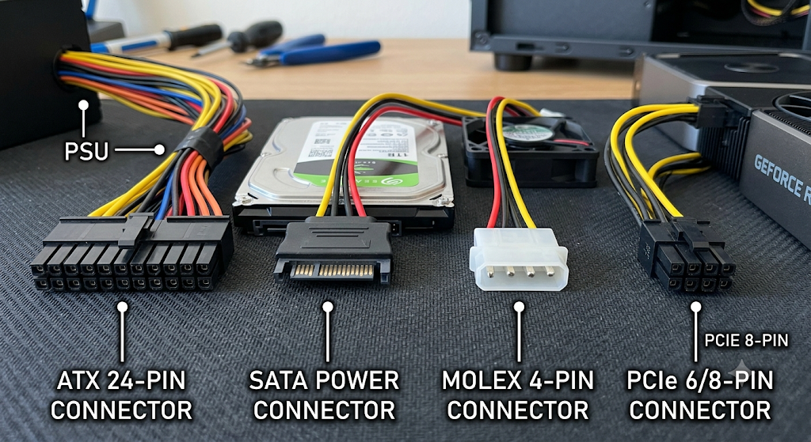
Power Connector | Devices It Powers | Safety Tip
ATX 24-pin Motherboard Connector | Powers the motherboard and distributes power to onboard components. | Always turn off the PC and unplug the power supply before connecting or disconnecting the connector
SATA Power Connector | Powers SATA hard drives (HDDs), SSDs, and optical drives (DVD/Blu-ray). | Align the L-shaped connector correctly and never force it into the port
Molex (4-pin) Connector | Powers older IDE hard drives, optical drives, case fans, and some accessories. | Hold the plastic connector when unplugging; never pull on the wires
PCIe 6/8-pin Power Connector | Provides additional power to dedicated graphics cards (GPUs) and some expansion cards. | Ensure the connector is fully inserted until it clicks into place before turning on the PC.

Q4. Imagine you are setting up a new gaming PC. List the steps you would follow to connect the SMPS to the motherboard, graphics card, and storage devices, mentioning which specific cables and connectors are used for each.
ANS. Steps to Connect the SMPS to a Gaming PC
- Install the SMPS
  - Mount the SMPS inside the PC case using the provided screws.
  - Ensure the power switch is OFF and the AC power cable is unplugged.
- Connect the Motherboard
  - Use the 24-pin ATX power cable.
  - Plug it into the 24-pin ATX connector on the motherboard until it clicks into place.
- Connect CPU Power
  - Use the 8-pin EPS (4+4-pin) CPU power cable.
  - Connect it to the CPU power connector near the processor socket on the motherboard.
- Connect the Graphics Card (GPU)
  - Use the PCIe 6-pin, 8-pin, or 6+2-pin power cable (depending on the graphics card).
  - Plug it into the PCIe power connector(s) on the graphics card.
- Connect Storage Devices
- For M.2 NVMe SSDs:
      - Action: Do nothing! M.2 drives plug directly into the motherboard slots and draw all their required power straight from the motherboard itself. No SMPS cables are needed.
- For SATA SSDs and HDDs:
  - Use the SATA power cable.
  - Connect it to the SATA power connector on the HDD, SSD, or SATA optical drive.
- Check All Connections
  - Ensure every connector is fully inserted and locked.
  - Organize the cables to improve airflow inside the PC.
- Power On the System
  - Connect the AC power cable to the SMPS.
  - Turn on the SMPS switch and press the PC's power button to verify that all components are working correctly.

